**Top constructor_results.points**

select constructors.name,constructors.nationality, sum(constructor_results.points)

from PLAYGROUND.DATATHON.CONSTRUCTORS

inner join PLAYGROUND.DATATHON.CONSTRUCTOR_RESULTS on constructors.constructorid=constructor_results.constructorid

group by constructors.name, constructors.nationality

order by sum(constructor_results.points) desc

**races.csv — The Calendar of Events**

**Top races – results (raceid)**

select races.round,races.circuitid, races.year, sum(races.raceid)

from PLAYGROUND.DATATHON.RACES

inner join PLAYGROUND.DATATHON.RESULTS on races.raceid=results.raceid

--where year = '2024'

group by races.round,races.circuitid,races.raceid, races.year

order by races.year desc

**Construction_standings and Races (raceid)**

select constructor_standings.points, constructor_standings.position, constructor_standings.wins, constructor_standings.constructorid

from PLAYGROUND.DATATHON.RACES

inner join PLAYGROUND.DATATHON.CONSTRUCTOR_STANDINGS on races.raceid=constructor_standings.raceid

group by constructor_standings.points, constructor_standings.position, constructor_standings.wins, constructor_standings.constructorid

order by points desc

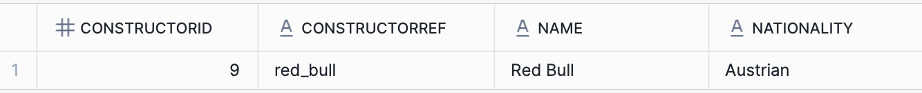

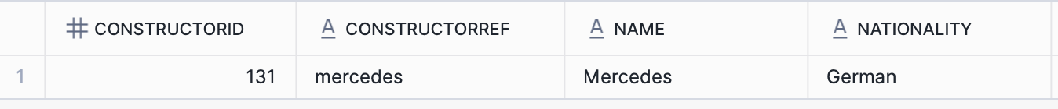

**races-lap times (raceid) -> 1st position driver per raceid**

**Quickest lap in milliseconds per driverid including raceid**



**drivers.csv — The Athletes of F1**

**Drivers & results – driverid**

select drivers.driverid, drivers.number, drivers.forename, drivers.surname, drivers.nationality, drivers.dob, results.fastestlaptime, results.points, results.fastestlapspeed

from PLAYGROUND.DATATHON.DRIVERS

inner join PLAYGROUND.DATATHON.RESULTS on drivers.driverid=results.driverid

group by drivers.driverid, drivers.number, drivers.forename, drivers.surname, drivers.nationality, drivers.dob,

results.fastestlaptime, results.points, results.fastestlapspeed

order by points desc

**Points and position**

select raceId, driverId, constructorId, grid, position, points, laps, fastestLap, statusId

from PLAYGROUND.DATATHON.RESULTS

where position is not null

and points is not null

and fastestlap is not null

order by points desc

--drivers and drivers standing

select distinct DRIVER_STANDINGS.driverstandingsid, DRIVER_STANDINGS.raceid, DRIVER_STANDINGS.driverid, DRIVER_STANDINGS.points, DRIVER_STANDINGS.position, DRIVER_STANDINGS.wins

from PLAYGROUND.DATATHON.DRIVERS

inner join PLAYGROUND.DATATHON.DRIVER_STANDINGS on drivers.driverid=driver_standings.driverid

group by DRIVER_STANDINGS.driverstandingsid, DRIVER_STANDINGS.raceid, DRIVER_STANDINGS.driverid, DRIVER_STANDINGS.points, DRIVER_STANDINGS.position, DRIVER_STANDINGS.wins

order by position desc

**results.csv — What Happened in the Race**

This is one of the most important tables — the **final race results**.

* **Key columns**: raceId, driverId, constructorId, grid, position, points, laps, fastestLap, statusId
* **How to use it**:
  + Track position changes (from grid to position)
  + Measure team points by summing points per constructor
  + Join with status.csv to know if a driver DNF’d (Did Not Finish)

